Overview: This scenario initially explores lactation issues among mothers within the camp. Acute mental stress is revealed as one of the root causes. This broadens into issues with mental health support across a two-camp system.
Each inject is structured in the following way:
Inject #
Inject text provided to participant. Embedded files can be opened with a double-click.
Additional Notes/Prompts: These are notes for the facilitator. These can help to answer participant questions or can be used as prompts to stimulate discussion. This is not meant to be given to the participants up front.
Expected Outcome: This is a potential outcome it is expected the participants will reach. This may not always be the outcome.

Scenario Play

Inject 1
Inject 1
7 mothers have presented to the clinics with issues breastfeeding in recent days. The issues are various. The infants have also been examined and are in differing states of health, though none acute.
Based on the patient profiles, identify individual care measures for each patient assuming access to vital services (lactation consultation, nutritional food for mom, supplemental formula, etc). Note that there are active possible ebola cases within the camp.

Double click to open

Additional Notes/Prompts:
Individual Assessment of an Infant
Infant and Chile Youth Feeding Indicators
Expected Outcome: Students come up with a plan to deal with the individual cases, including who they would coordinate with and how.

Inject 2a
Inject 2a
The camp is supplied with a specific type of Ready-to-Use Therapeutic Food (RUTF). A notice comes from the manufacturer that several lots may have been contaminated with Clostridium botulinum (botulism). Immediately, camp officials review the supplies within the camp, and it is determined that slightly more than half of the supply on-hand is within the affected lot numbers.
Discuss immediate actions and concerns for long-term impacts.

Additional Notes/Prompts:

Expected Outcome: Students should be concerned that the supply of RUTF will run out and discuss potential options (ordering a new supply, finding alternative feeding methods, reducing distribution)

Inject 2b
Inject 2b
After contaminated supplies are removed, 77 cases remain within the two camps as of May 10. Each case contains 150 92-gram sachets. Each sachet is approximately 500 calories of nutrition. The full case is normally enough for a 4-8 week treatment course. The below table provides some general guidance surrounding consumption.

Age Group | Typical Weight Range | Average Daily Energy Needed | Average Pouches per Day | Notes for Exercise
6–11 months | 6–9 kg | 900–1,665 kcal | 2–3.5 pouches | Start lower (e.g., 2 pouches) and increase as tolerated; continue breastfeeding.
12–23 months | 9–12 kg | 1,350–2,220 kcal | 3–4.5 pouches | Most common group in camps; often 3–4 full sachets.
24–59 months | 12–15+ kg | 1,800–2,775+ kcal | 4–5+ pouches | Can reach 5–6 sachets for larger/older children; monitor for sharing.

What information do you need to be able to make decisions about RUTF distribution and nutrition?
What do you do in the case that you are likely to run out of supplies before a new shipment comes in? How do you 'triage' who receives RUTF, or how do you lengthen your supply?

Additional Notes/Prompts: The RUTF being used is called PlumpyNut. Originally developed by a French company, a large quantity is manufactured in the United States by a company called Edesia. https://www.edesianutrition.org/global-foods/
PlumpyNut is peanut based. It should be noted that peanut allergies are extremely rare in Africa, including the DRC. In western countries, many nations see 3+% rate of people with peanut allergies. However, in many African nations, it can be less than 0.1% (some attribute this to the fact that it is more common to boil peanuts than to roast them, as well as earlier introduction into diets).

Expected Outcome: Students need to have a discussion on how they will handle this potential crisis. It is a very real possibility that the RUTF pouches, a staple of survival for many children, will run out if distribution rates remain as high. Some information needed: when will resupply occur and how much, how many children are receiving RUTF, can any be cut back or stopped?

Inject 3
Inject 3
The camp lacks adequate lactation support providers as well as mental health support for new mothers, particularly those who are struggling with lactation and victims of violence. Support groups exist but tend to be best for general community support. Specific care for acute and complex situations is nearly non-existent.
Discuss a layered approach to improve mental health care for new mothers, taking into account a lack of qualified practitioners.

IASC MHPSS Intervention Pyramid

Additional Notes/Prompts: None.

Expected Outcome: Participants discuss implementing a layered approach, based on the IASC MHPSS Intervention Pyramid, to improving mental health within the camp. They should examine what interventions the healthcare team in the camp can handle internally, and which will rely on external support.

Inject 4
Inject 4
On June 1, you are notified that the expected June 5 delivery of RUTF may be delayed by 5 days. Since May 10, more children have begun receiving nutrition supplements than have stopped. The numbers as of today are:

Camp Rusayo
151 children receiving RUTF supplements. Last week, 26 cases distributed.
Bushagara IDP Camp
215 children receiving RUTF supplements. Last week, 36 cases distributed.

The next distribution is slated for June 7, but you will likely not have enough on hand to distribute to everyone.
Discuss options. Assume the new delivery date of June 10 is expected to be met.

Additional Notes/Prompts: This will lead to an exhaustion of supplies if current rates of consumption are maintained, however it is manageable if the rate can be reduced. Students should be thinking about how to reduce these rates, such as what criteria to use to reduce an individuals distribution of RUTF.

Expected outcome: Prioritize patients… who can be reduced. Also, communication plan is needed to inform people that are being reduced, why, and when they can expect normalization.

Inject 5
Inject 5
An NGO, the Africa Mental Health Foundation (AMHF), stepped in to assist in training community representatives to provide non-specialized mental health support. They also provided a limited number of mental health clinicians for a short-term deployment from other regions in Africa. Though they have had success, they have reported several strains on their ability to conduct their missions.
AMHF began in the Bushagara IDP Camp, focusing on "train-the-trainer" engagements to enable camp residents to provide community and family support (Layer 2 support). Soon, they began to create more formal, structured mental support structures. They wanted to train individuals to be able to provide mental health support through group sessions, anger management, and family counseling (Layer 3 support). Meanwhile, AMHF deployed several mental health practitioners - Psychologists, Psychiatrists, Mental Health Nurses, Social Workers, and Community Health specialists. These came to the DRC from several locations and were generally on a three to four month deployment (Layer 4 support).

In Bushagara, Swahili is spoken by a plurality of the population. However, a number of other dialects from around the DRC are represented. Many people speak some French, but few speak it as a first language or are fluent enough to be useful in a mental health appointment. AMHF has a limited number of translators to cope with the number of residents needed to be trained and seeking treatment.
As AMHF moved on to Camp Rusayo, more issues surfaced. Similar to Bushagara, there are dialects in Camp Rusayo that AMHF are unable to support directly. There are few translators for several of the languages. Additionally, Camp Rusayo residents believe that Bushagara received much better support since they were predominantly from the DRC and Camp Rusayo residents were predominantly foreigners. While this is not true, AMHF did go to Bushagara first (just days before going to Camp Rusayo).
In both camps, as AMHF began training people to provide layer 3 support, many demanded payment of some sort to be able to provide these services. AMHF told prospective students that they wanted to train them first and would work with camp administration and the UN for a payment system. However, many students dropped out.

Taken together, while there has been some progress made in training community support, problems persist.
- Lack of translators to train practitioners in their native languages
- Lack of translators available to support current mental health providers deployed for support
- Camp Rusayo residents believe that Bushagara IDP Camp was favored and received support first
- Prospective students do not want to train to provide layer 3 support if they will not be compensated or do not know what kind of compensation they will receive

This is a multi-faceted, complicated problem. Discuss how to address this with medical leadership, camp leadership, and AMHF personnel. What recommendations can you make to attempt to address these issues? What can be done in the meantime, or if these issues cannot be resolved?
How should medical personnel handle patients who are in need of mental health support which may not be readily available?

Additional Notes / Prompts:

Expected Outcome: This inject has four facets of communication. 1) Communication with AMHF; 2) Communication with camp leadership; 3) Communication with camp medical personnel; 4) Communication with residents.
This is a complicated situation. AMHF likely should not have told people that they will just train them now and worry about pay later. However, since it is done, there are a few things students should discuss. ?
- Is it normal in other camps for these kinds of community providers to be paid (I don’t know the definitive answer to this, but I would imagine there is some kind of compensation if they are expected to provide these services for more than a few hours a week)
- What would fair compensation be?
- Who does the payment come from and how?
- How are these workers supervised?
There needs to be communication with camp residents, particularly in Camp Rusayo, who feel that they have been underserved. In addition to what to say, who delivers the message and how it is delivered is important.
Access to translators is critical. This is always an issue, but there are unique needs in providing mental health support.

Individual Assessment of an Infant
The below flow chart is from UNHCR Infant and Young Child Feeding Practices: Standard Operating Procedures for the Handling of Breastmilk Substitutes (BMS) in Refugee Situations for Children 0-23 Months
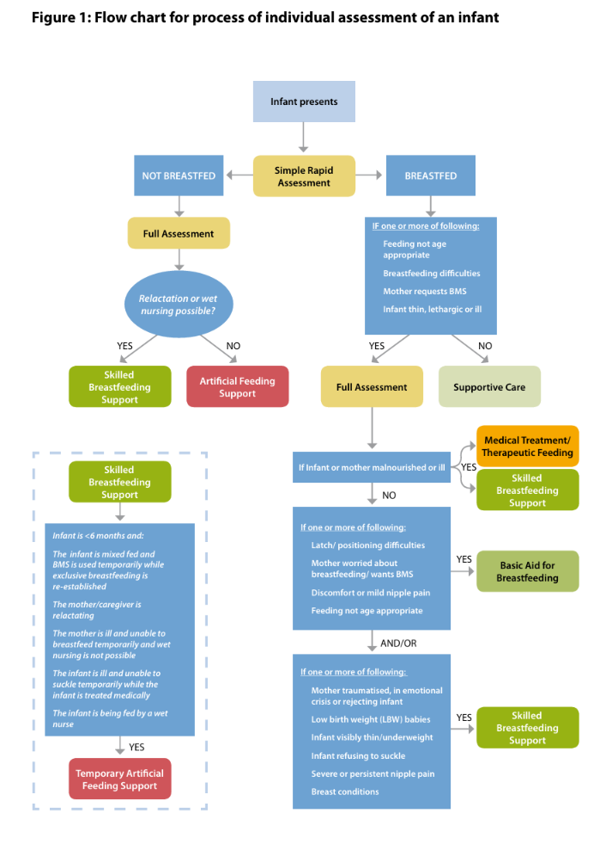

Infant and Child Youth Feeding Indicators
World Health Organization Indicators
- Timely initiation of breastfeeding in children aged 0-23 months (meaning children aged 0 to <24 months)
- Exclusive breastfeeding under 6 months (meaning infants aged <6 months)
- Predominant breastfeeding under 6 months (meaning infants aged <6 months)
- Continued breastfeeding at 1 year in children aged 12-15 months (meaning children aged 12 to <16 months)
- Continued breastfeeding at 2 years in children 20-23 months (meaning children aged 20 to <24 months)
- Introduction of solid, semi-solid or soft foods in infants aged 6-8 months (meaning infants aged 6 to <9 months)
- Consumption of iron-rich or iron-fortified foods in children aged 6-23 months (meaning children aged 6 to <24 months)
- Bottle feeding in children aged 0-23 months (meaning children aged 0 to <24 months)
UNHCR Indicators
- No breastfeeding under 6 months (meaning infants aged <6 months)
- No breastfeeding under 12 months (meaning infants aged <12 months)

IASC MHPSS Guidelines
The Inter-Agency Standing Committee (IASC) guidelines on Mental Health and Psychosocial Support (MHPSS) in emergency settings structure services in four layers. Most needs are addressed at lower layers by non-specialists, with specialists reserved for severe cases:
- Layer 1: Basic services and security (e.g., safe water, food, shelter) — provided by all humanitarian actors.
- Layer 2: Community and family supports (e.g., social activities, peer support, Psychological First Aid) — delivered by trained community volunteers, teachers, or protection workers.
- Layer 3: Focused, non-specialized support (e.g., structured psychological interventions like group sessions or problem management) — provided by trained and supervised lay workers, nurses, or community health workers.
- Layer 4: Specialized clinical services (e.g., for severe mental, neurological, or substance use disorders) — led by mental health professionals (psychiatrists, psychiatric nurses, clinical psychologists).
This pyramid promotes task-sharing: train general health workers and community members to handle the majority of needs, while specialists provide supervision, complex care, and referrals. In refugee contexts, prevalence of conditions like depression, anxiety, and PTSD is often elevated (estimates suggest ~22% of adults in conflict settings may have mental health conditions, roughly double or triple non-emergency rates).

