Overview: In this scenario, a group of researchers identifies Bombali Virus (BOMV) in a population of bats near the camps. BOMV has not been proven to infect humans, but shows the characteristics of a potentially zoonotic threat.
Each inject is structured in the following way:
Inject #
Inject text provided to participant. Embedded files can be opened with a double-click.
Additional Notes/Prompts: These are notes for the facilitator. These can help to answer participant questions or can be used as prompts to stimulate discussion. This is not meant to be given to the participants up front.
Expected Outcome: This is a potential outcome it is expected the participants will reach. This may not always be the outcome.

Scenario Play

Inject 1
Inject 1
May 10, 2026 @ 3 pm: Researchers from the University of Helsinki and the Kenyan Medical Research Institute (KMERI) recently arrived in the Eastern DRC and Uganda to conduct filovirus research on the local bat populations. Unexpectedly, Bombali virus (BOMV) RNA is detected in a statistically significant population of bats in the region.

Article: Assessing risk of Bombali virus spillover to humans by mutagenesis analysis of viral glycoprotein

Article: Bat-borne virus diversity, spillover and emergence

Additional Notes/Prompts:

Expected Outcome: Students are expected to discuss the risks of BOMV and how to monitor the spread, but there needs to be little action on the part of camp public health officials at this point.

Inject 2
Inject 2
May 11, 2026 @ 10 am. A community representative from Bushagara IDP Camp informs you that an abandoned school building adjacent to the camp and some other structures houses many bats. Camp residents are often seen going there to trap bats, cook the bushmeat, and sometimes barter it with other residents.

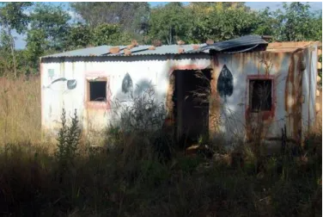

Additional Notes/Prompts:

Expected Outcome: BOMV is not the primary concern, however, bats can carry many other diseases. Students should discuss informing the community of the risk of interacting with bats and ensuring they have the proper medical resources to handle any likely issues.

Inject 3
Inject 3
May 13, 2026, @ 3 pm. Community leaders begin to complain that camp security officers have erected additional fencing around the buildings where the bats are to keep people out. Security has been aggressive towards people seen approaching the area.

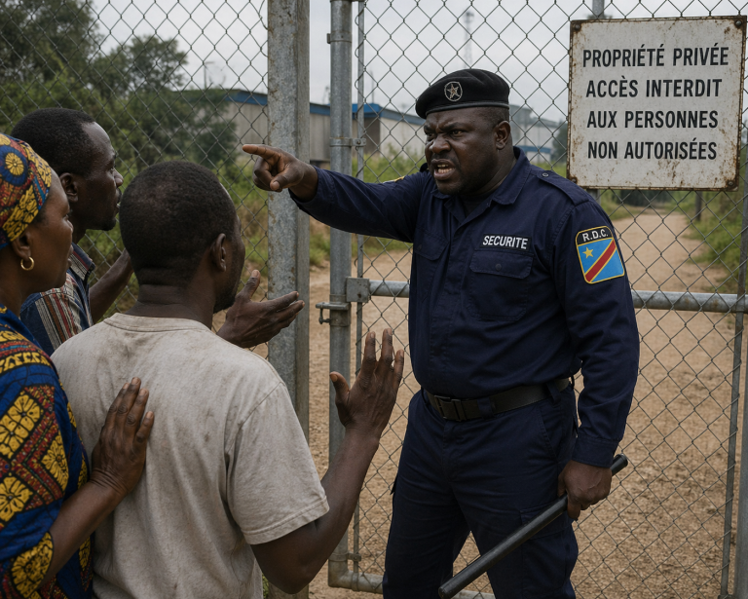
AI Generated Image

Additional Notes/Prompts: This is an overreaction from camp officials independent of the Public Health/ medical community.

Expected Outcome: Camp public health personnel may want to discuss the reasoning for the extra fencing and security with camp administration. Information regarding BOMV should be shared.

Inject 4
Inject 4
May 14, 2026 @ 3 pm. Several ombudsman appeal to camp administration to allow people to continue hunting the bats. During a heated meeting, community leaders say that they need the additional meat to supplement the diet they are getting. The camp does not provide enough food and not enough people are able to work outside of the camp to earn money for food.

Article: Stopping Bushmeat Is Good for Conservation—and Bad for Hunger

Bats as Food

What approach would you take on this issue?
Would you support the hunting of bushmeat? If so, what recommendations would you make to camp officials?
- Should hunting be restricted in some way (certain people, times of day, amount of food allowed, type of bat)?
- How would you ensure people are properly preparing bushmeat for consumption?
- How would you communicate the health and safety risks with the population and camp leadership?
If you support completely restricting the hunting of bushmeat, how would you proceed?
- Would you recommend camp staff make any changes to keeping people away from the bat habitats?
- What messaging would you recommend to the residents?
- What if people find alternate places for hunting?

Additional Notes/Prompts:

Expected Outcome: Public Health personnel will likely support some kind of hunting, provided training and information is shared with the population regarding risks and proper preparation techniques.

Inject 5
Inject 5
May 20, 2026 @ 8 am. Over the past week, 12 adults and children from 5 neighboring shelters near the bat roosts report similar symptoms. Camp health workers note the following common complaints):
- Fever (low to moderate grade)
- Chills and night sweats (milder than typical TB)
- Dry cough or mildly productive cough
- Headache and muscle aches (myalgias)
- Fatigue and general malaise
- Chest discomfort or mild shortness of breath on exertion
- Loss of appetite

Additional details that emerge during history-taking:
- Symptoms began 5–14 days after families cleared vegetation and disturbed soil/dust near known bat roosting trees and a the abandoned buildings.
- Some individuals helped clean areas with visible bat droppings (guano).
- A few report recent bat hunting or butchering for food due to insufficient rations.
- Children and malnourished adults seem more affected; one pregnant woman and two people living with HIV are in the group.
- No hemoptysis, severe weight loss, or prominent night sweats initially; no skin lesions or bone pain reported yet.

What is your initial differential diagnosis? Rank the most likely causes in this setting.

Note: Key differentials in a North Kivu refugee camp context: Pulmonary tuberculosis (highly prevalent, similar cough/fever), bacterial community-acquired pneumonia, malaria (endemic), viral respiratory infections (e.g., influenza-like illness), COVID-19 or other outbreaks, HIV-related opportunistic infections, and other mycoses.

How does the exposure history (bat roost proximity, guano disturbance, bushmeat handling) influence your thinking? Would you ask about it routinely?
How do overlapping symptoms complicate triage? What role do malnutrition, overcrowding, and weakened immunity play in severity?

How might mild cases serve as “sentinels” for higher-risk activities that could also facilitate deadlier zoonoses (e.g., filoviruses)?

Additional Notes/Prompts: This inject is leading towards histoplasmosis, a fungal infection caused by Histoplasma capsulatum, which thrives in soil or environments enriched with bat (and bird) droppings/guano.

Expected outcome: Highlight that acute pulmonary histoplasmosis is often misdiagnosed as TB or pneumonia in Central Africa. Exposure history tied to bat habitats is a critical clue. In resource-limited settings, clinical + epidemiological suspicion drives initial management.

Inject 6
Inject 6
May 21, 2026 @ 8 am.

Symptoms persist or worsen in several patients after 1–2 weeks of supportive care and empirical antibiotics/malaria treatment. Three patients were able to get chest X-rays show diffuse reticulonodular infiltrates or hilar lymphadenopathy. No acid-fast bacilli on sputum smears.
Discussion:
- What diagnostic steps would your team prioritize given limited resources? When would you pursue presumptive treatment?
- How to differentiate from TB (common co-infection or misdiagnosis risk)? Role of histopathology in confirming large yeast forms if African histoplasmosis (H. capsulatum var. duboisii) is considered.
- How can environmental health/veterinary team members contribute (e.g., mapping bat roosts, testing guano)?
- Surveillance: Should this cluster trigger broader camp screening or reporting?

Additional Notes / Prompts:

Expected Outcome

Bats as Food
Bat meat, like other forms of bushmeat, is primarily valued in Central Africa (including parts of the DRC) as a source of high-quality animal protein and certain micronutrients, especially in food-insecure or refugee settings where domestic livestock may be scarce or expensive. However, detailed, species-specific nutritional analyses for bats common around Goma (e.g., fruit bats like Eidolon helvum, Epomophorus spp., or Hypsignathus monstrosus) are limited. Most data come from broader bushmeat studies in West and Central Africa or general proximate analyses of wild game.
Approximate Nutritional Profile (per 100g wet weight, based on available bushmeat/wild game data)
Bat meat is generally described as **lean** (low fat) with solid protein content, similar to other wild mammals:
- Protein: ~20–25 g (high biological value, comparable to lean beef or other game meats; provides essential amino acids).
- Fat: ~1–2 g (low overall; predominantly unsaturated fats; some reports note low cholesterol ~36 mg).
- Energy: Moderate, driven mainly by protein rather than fat.
- Micronutrients: Bushmeat, including bats, is often highlighted for its contribution to iron (heme iron, highly bioavailable; 2–4 mg or more), zinc (3–5 mg, potentially higher in insectivorous bats), and other minerals like potassium, magnesium, and selenium. It can also supply B vitamins (e.g., B12, riboflavin, niacin) typical of red meats.
In many rural or displaced populations in Central Africa, bushmeat (including bats) can supply a significant portion of animal-source protein—sometimes 80–90% in certain West/Central African contexts—helping prevent protein-energy malnutrition and micronutrient deficiencies such as iron-deficiency anemia. One study in Madagascar estimated that restricting bushmeat access could increase childhood anemia rates by 29%, with the greatest impact on the poorest households.
Fruit bats (the types most commonly consumed around Goma and in eastern DRC) derive their diet from fruits, which may influence the meat's profile toward slightly different micronutrient or antioxidant levels compared to insectivorous bats, though data remain sparse. Preparation methods common in the region—smoking, drying, or using in soups—can affect final nutrient retention (e.g., some vitamin loss but good protein preservation).
Food for thought:
- Nutritional benefits: Bats can serve as an accessible, locally available protein source during acute food shortages, camp overcrowding, or when supply chains for livestock or relief commodities are disrupted. This is especially pertinent in conflict-affected areas of North Kivu, where displacement increases reliance on wild resources. It provides not only calories and protein but also bioavailable iron and zinc, which support immune function, growth (critical for children in camps), and maternal health—key concerns in humanitarian settings.
- Trade-offs and risks: While nutritionally valuable, consumption carries **significant zoonotic disease risks**, including potential exposure to Ebola, Marburg, lyssaviruses (rabies-related), or other bat-associated pathogens. Spillover is often linked to hunting, butchering, or undercooked/smoked meat rather than casual contact. In refugee scenarios, factors like weakened immunity, poor sanitation, and high human-bat interfaces (e.g., camps near roosts or fruit trees) could amplify transmission risks. Recent anecdotal reports from the DRC have linked bat consumption to mystery illness clusters, underscoring the need for caution.
Discussion points for multidisciplinary teams:
- Balancing nutrition and safety: How to provide culturally sensitive nutrition education that acknowledges the role of bushmeat without stigmatizing local practices? Alternatives like fortified rations, small livestock programs, or sustainable protein sources (e.g., fish from Lake Kivu, legumes, or insects)?
- One Health integration: Surveillance for sick/dead bats or unusual wildlife illness near camps; safe handling guidelines (PPE for butchers, thorough cooking); monitoring for outbreaks amid displacement.
- Vulnerable groups: Children, pregnant women, and immunocompromised individuals in refugee populations may gain the most nutritional benefit but face highest disease risks.
- Longer-term considerations: Environmental impacts (overhunting of fruit bats affects pollination/seed dispersal, potentially worsening food security); economic role of bat trade (income for hunters/vendors in informal markets).
Key caveat: Specific laboratory data on bats from the Goma/Virunga area are scarce due to security and research challenges. Nutritional value varies with species, age, diet, season, and preparation. In practice, public health responses should prioritize thorough cooking (to reduce—but not eliminate—pathogen risks) while promoting diversified diets and avoiding high-risk behaviors like handling raw carcasses.

